# Exercises: CSS Formatting and Positioning

Problems for exercises and homework for the ["HTML and CSS" course @ SoftUni](https://softuni.bg/courses/web-fundamentals-html5). Submit your solutions in the SoftUni judge system at <https://judge.softuni.bg/Contests/801/Exercise-CSS-Formatting-and-Positioning>.

## Book Review

Create a Web page (HTML5 + CSS3 + images) that looks and behaves like the screenshots below:

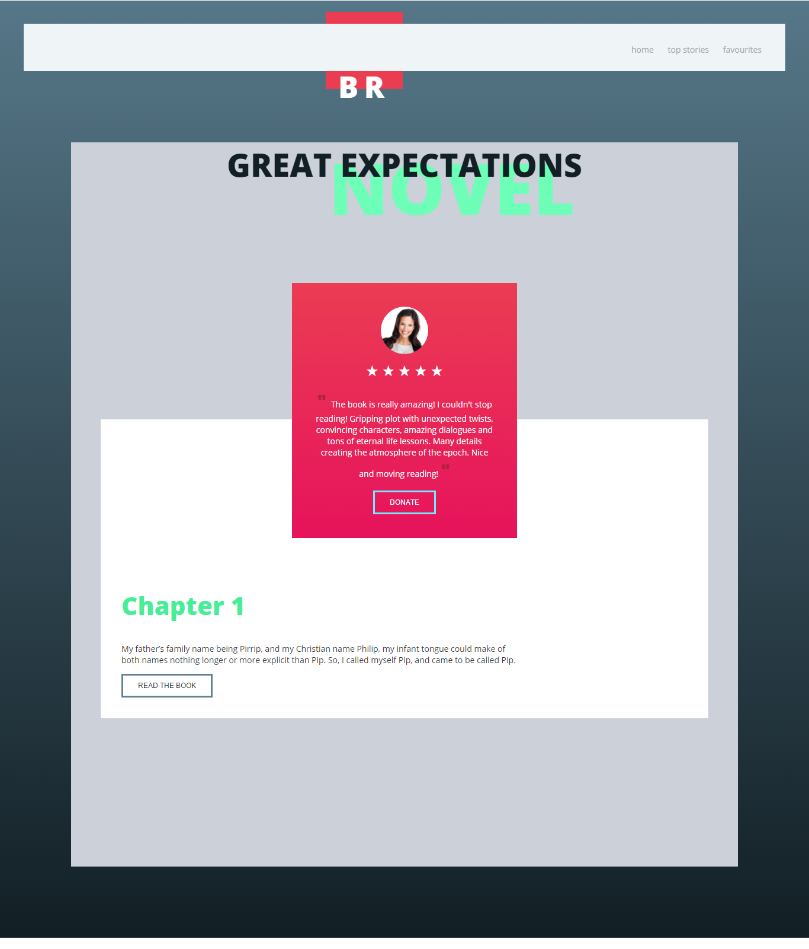

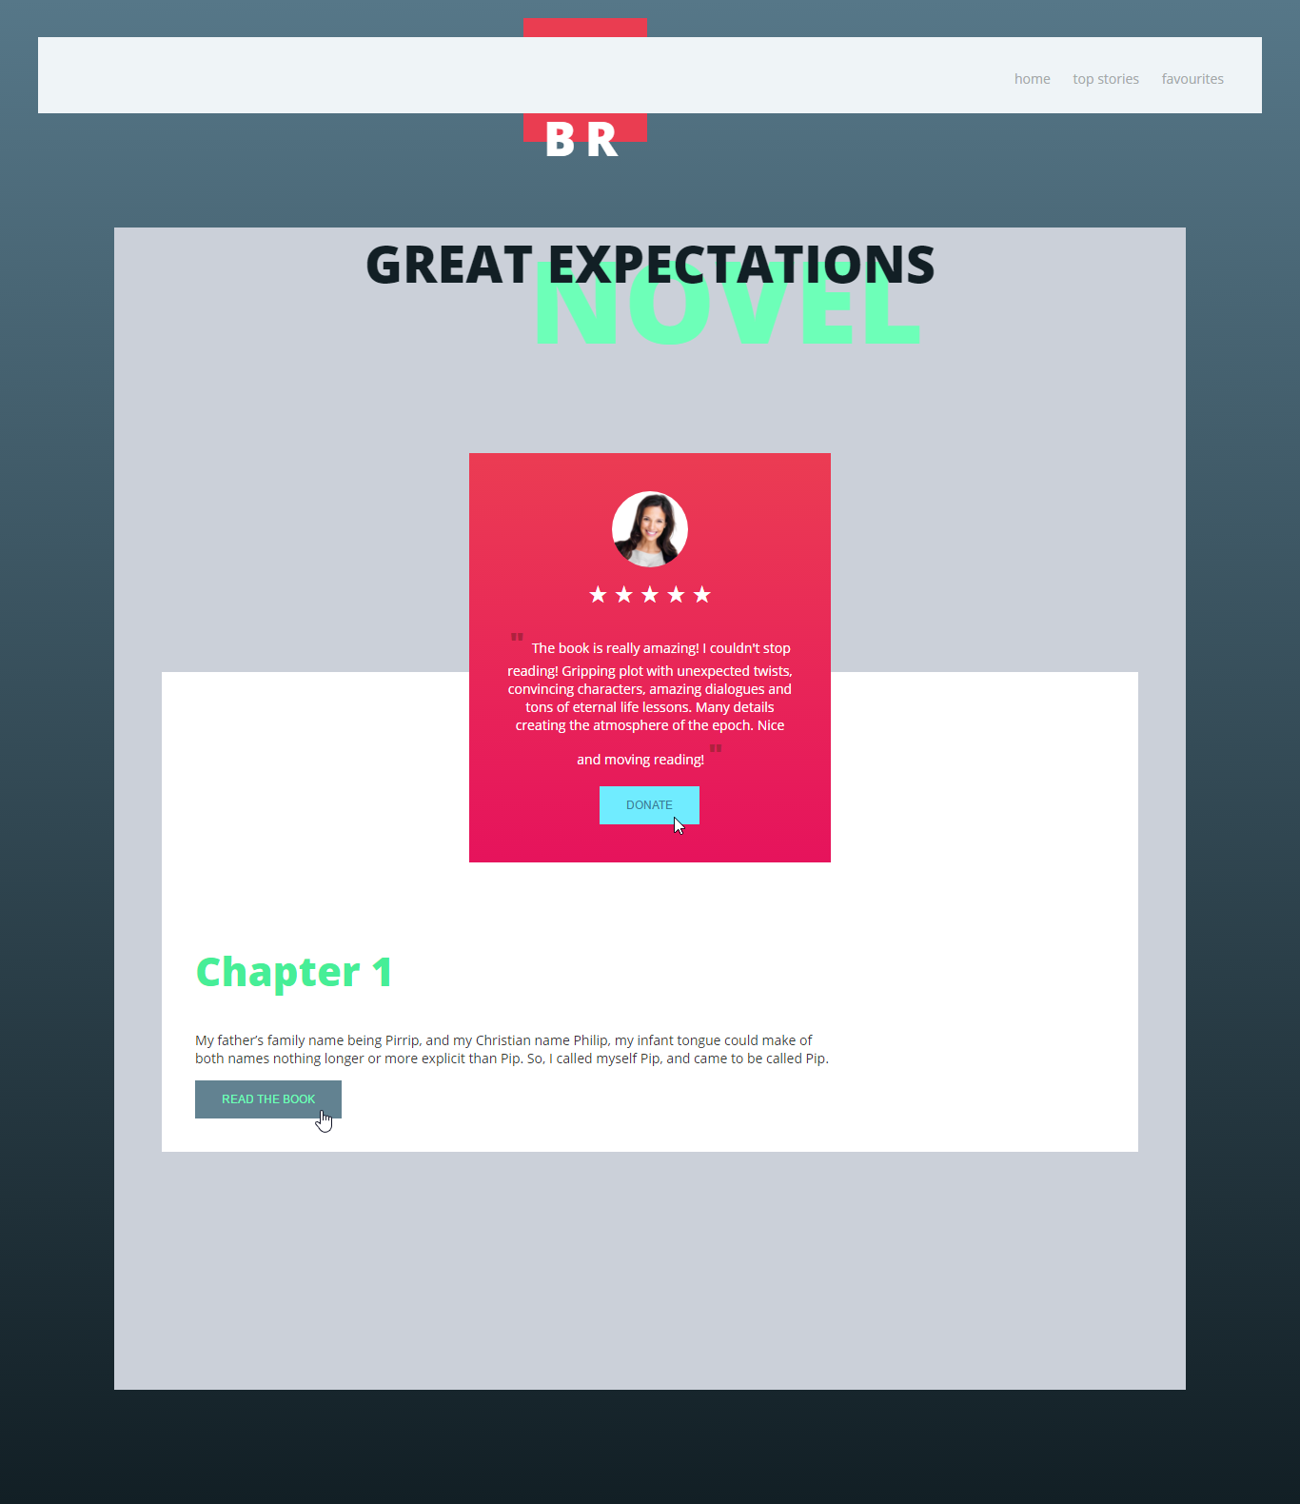

### Steps to Follow

Start with the **site header**:

* @import for the ‘**Open Sans**’ **font** from Google Fonts: <https://fonts.googleapis.com/css?family=Open+Sans:300,400,800>
* <body>
  + Margin: 0px;
  + Padding: 0px;
  + Background: linear-gradient(to bottom, #567788 0%,#121f25 100%) no-repeat center center;
  + Text font: 'Open Sans', sans-serif;
  + Text size: 14px;
  + Text color: #333333;
* Site navigation
  + Background: #eff4f7;
  + Margin: 40px;
  + Position: Relative;
  + Z-Index: 5;
  + Height: 80px;
* Style the hyperlinks: <a> in the site navigation
  + Remove the decoration
  + Text Color: #a4a8a9;
* Style the unordered list <ul> in the site navigation
  + Padding: 20px 20px 0 20px;
  + Float: Right;
* Style the list items <li> in the site navigation
  + Display: Inline Block
  + Remove the bullets
  + Margin Right: 20px;
  + Padding at the bottom: 23px;
* Style the list items on hover and hyperlinks
  + Cursor: Pointer
  + Border Bottom Color: #70e9ff;
  + Text Color: #333;

Test the site navigation in the browser:

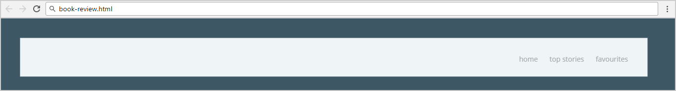

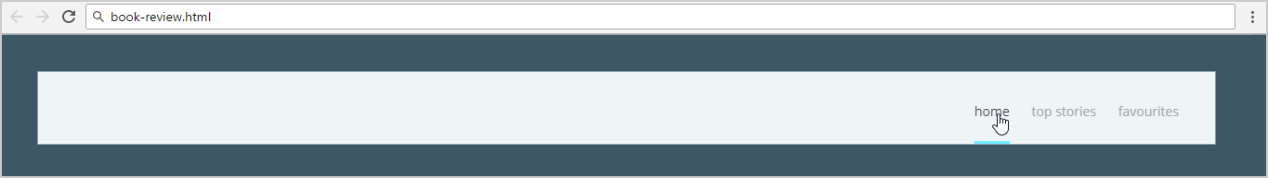

Now style the Logo at the navigation using <section> with class logo and <h1> with class brand

* Style <section> with class logo
  + Position: Absolute;
  + Z Index: 0;
  + Top: 20px;
  + Left: 550px;
  + Background: #ea3d51;
  + Width: 90px;
  + Height: 90px;
  + Padding: 20px;
* Style <h1> with class brand
  + Make it UPPERCASE
  + Center the text
  + Text Size: 50px;
  + Font-weight: 900;
  + Space between letter: 10px;
  + Text Color: #ffffff;
  + Margin at the Top: 72px;

Test the site navigation in the browser:

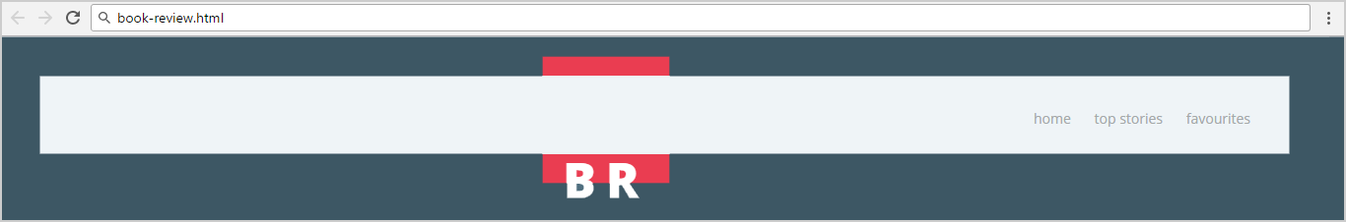

Style the Main content block:

* Make the background gray: #CBD0D9;
* Use 80% width.
* Center the main section.

Now style the Header block at the main using <header> with <h1> with class **"book-title"** and <h5> with class **"book-genre"**

* Style <h1> with class "book-title"
  + Position: Relative;
  + Z Index: 10;
  + Text Color: #121f25;
  + Text Size: 54px;
  + Margin: 0;
* Style <h5> with class "book-genre"
  + Position: Relative;
  + Z Index: 3;
  + Top: -80px;
  + Left: 80px;
  + Text Color: #6dffb8;
  + Text Size: 120px;
  + Margin: 0;

Test the header in the browser:

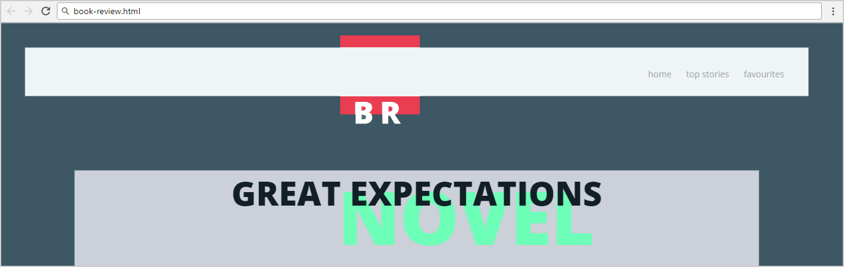

Now style the review using <section>, <img>, <button> and two paragraphs

* Style <section>
  + Position: Relative;
  + Z Index: 8;
  + Center the section
  + Text Color: #ffffff;
  + Width: 300px;
  + Padding: 40px;
  + Center the text;
  + Background: linear-gradient(to bottom, #eb3c53 0%, #e6135c 100%) no-repeat center center;
* Style <img>
  + Display: **Block;**
  + Center the image
  + Width: 100%;
  + Max Width: 80px;
  + Border Radius: 50%;
* Style the paragraph with text using before and after
  + Content: ' " ';
  + Color: #af213d;
  + Text Size: 30px;
  + Font Weigth: 800;
* Style the paragraph with stars
  + Text Size: 25px;
  + Margin: 10px;
  + &starf; in html
* Style the button
  + Background: None;
  + Border: 3px solid #70ecff;
  + Make it UPPERCASE
  + Text Size: 12px;
  + Text Color: #ffffff;
  + Padding: 10px 25px;
* Style the button on hover
  + Background: #70ecff;
  + Border Color: #70ecff;
  + Text Color: #348098;

Test this **section** in the browser:

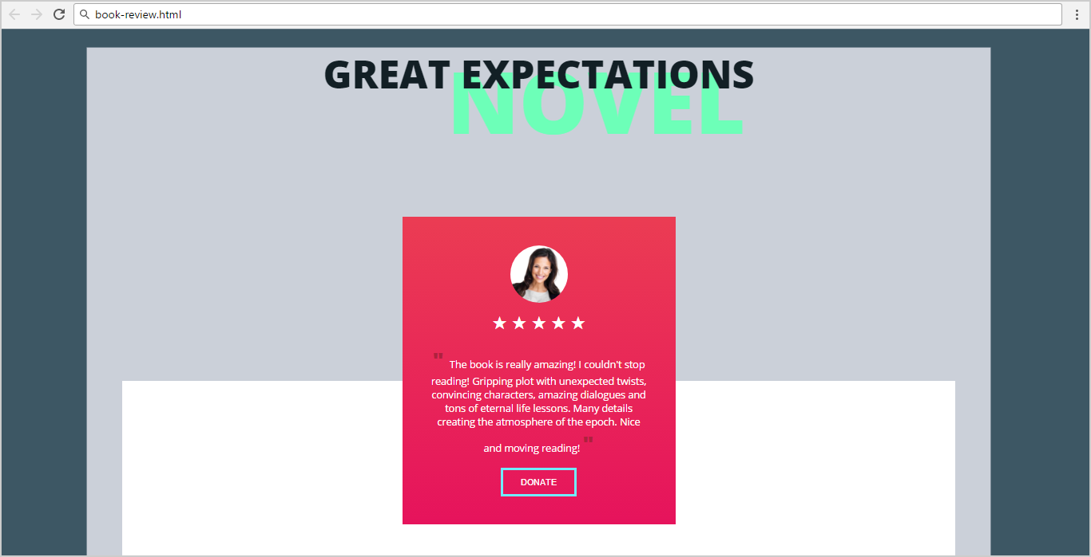

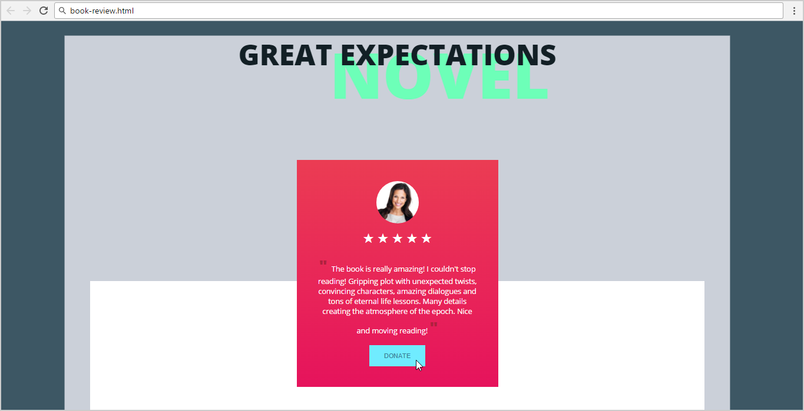

**Now** style the second <section>, <h1>, <p> and <button>

* Style <section>
  + Position: Relative;
  + Z Index: **4**;
  + Top: -250px;
  + Background: #ffffff;
  + Margin: 50px;
  + Padding: 250px 35px 35px 35px;
* Style <h1>
  + Text Color: #46ee97;
  + Text Size: 42px;
* Style <p>
  + Width: 70%;
* Style the button
  + Background: None;
  + Border: 3px solid #628291;
  + Make it UPPERCASE
  + Text Size: 12px;
  + Text Color: #333;
  + Padding: 10px 25px;
* Style the button on hover
  + Background: #628291;
  + Cursor: Pointer;
  + Text Color: #6dffb8;

Test the site in the Web browser again:

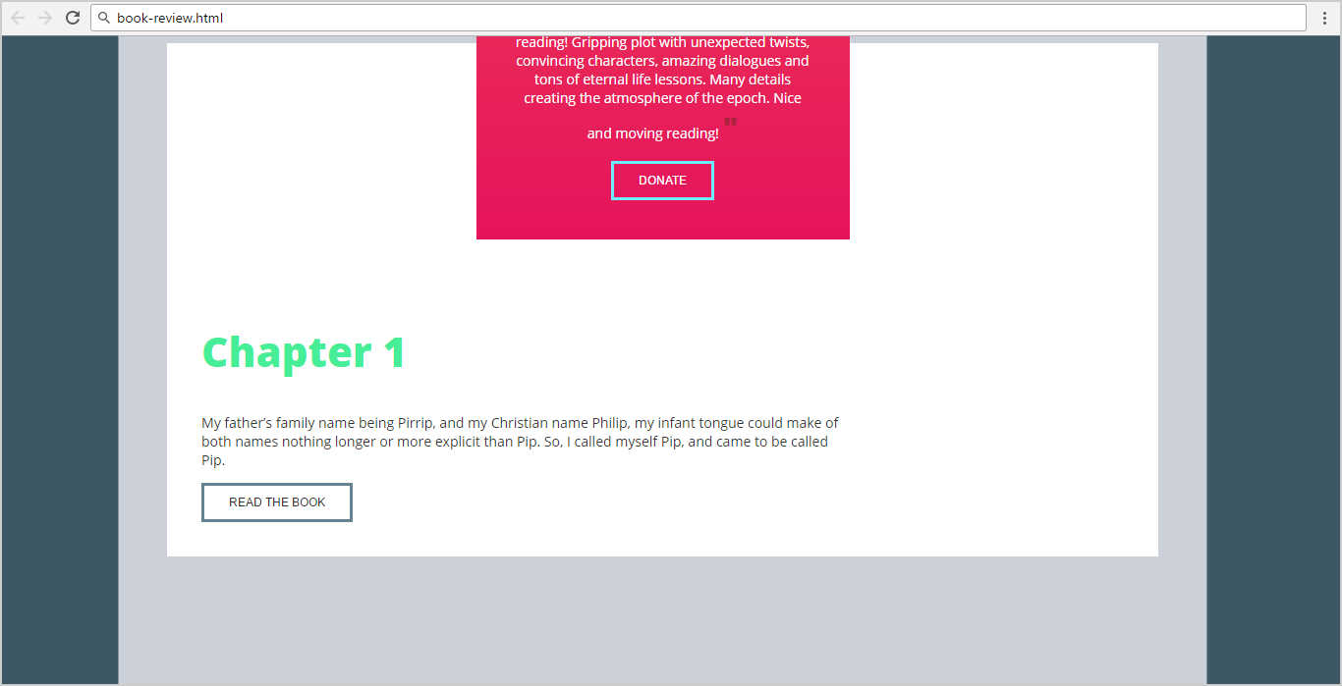

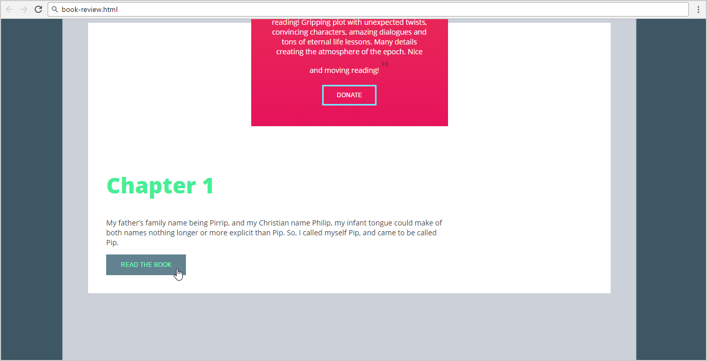

## Option Panels

Create a Web page (HTML5 + CSS3 + images) that looks and behaves like the screenshots below:

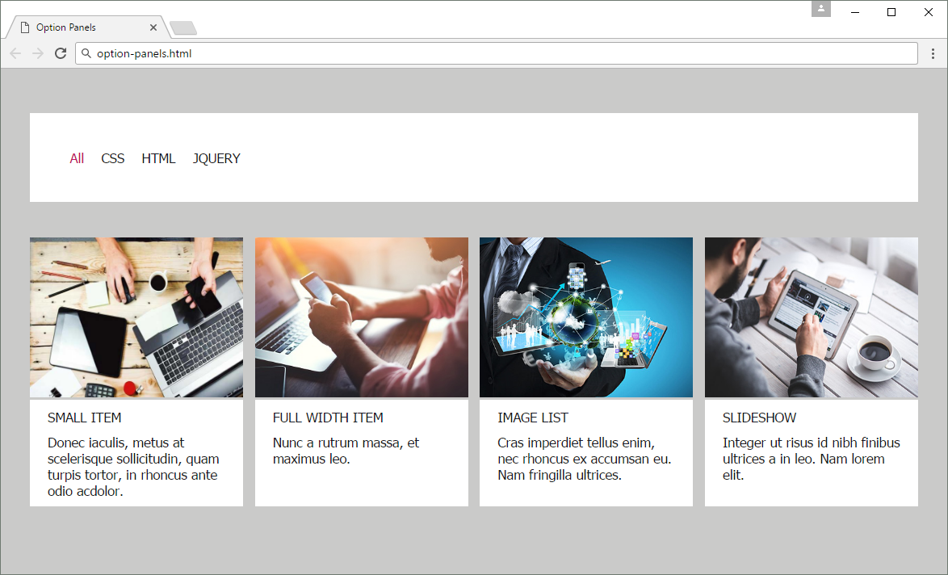

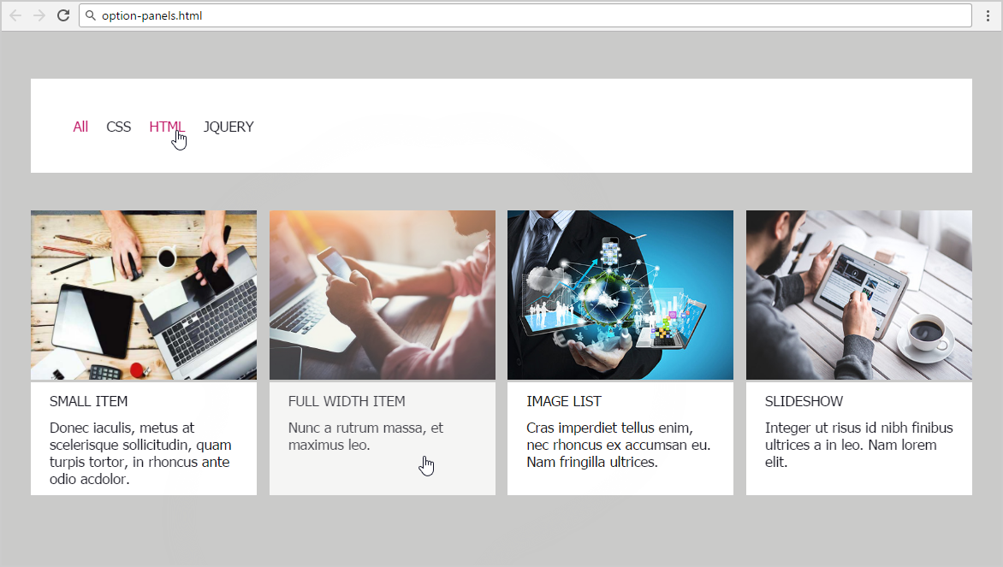

* The mouse cursors in the above screenshots explain what happens when the mouse moves over a project or a group and when the browser window resizes.

### Input

You are given the above screenshots + all required images + the texts on the site.

### Output

The output should be valid HTML5 + CSS3 + images that implement the above Web page.

### Constraints

* The layout is body-centered and should be 1000px.
* Font: 15px Tahoma, Arial, sans-serif; Default text color is #191923;
* The links at the navigation - current state and hover-effect color: #BF1363
* There are 4 sections which are fully linkable and hover effect is transparency **0.8** of all the section.
* Pixel-perfect implementation is not required.

## Numbers

Create a Web site (HTML5 + CSS3) that looks and behaves like the screenshots below:

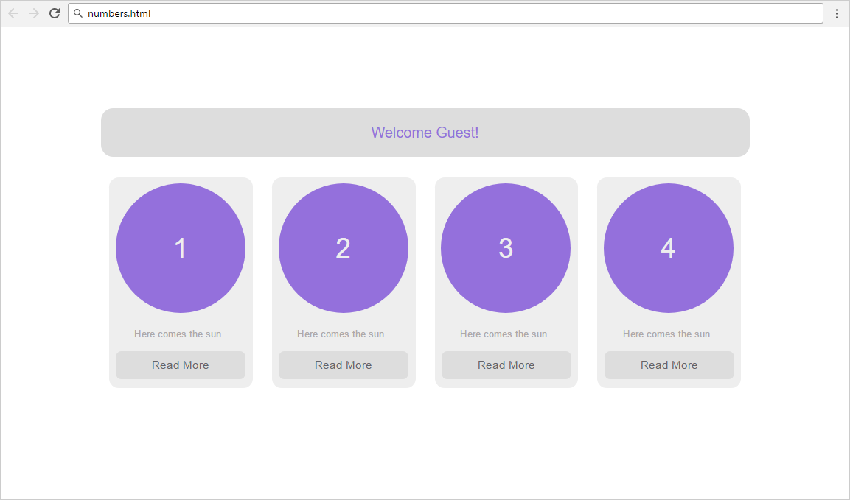

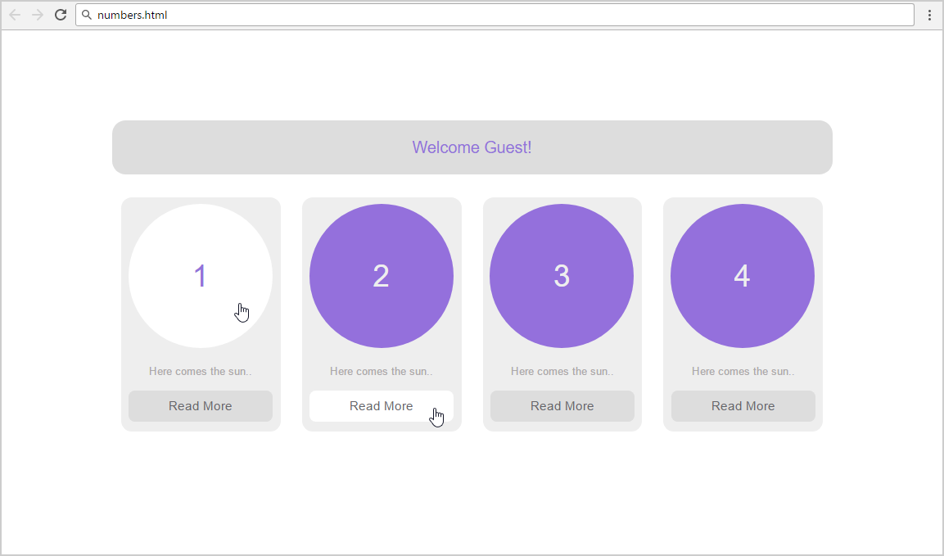

* The hand cursors in the screenshots show what happens when the mouse moves over certain elements.

### Input

You are given screenshots + the texts on the site.

### Output

The output should be valid HTML5 + CSS3 that implement the above Web site.

### Constraints

* Fonts:
  + Site content: Arial, Helvetica, sans-serif; 12px.
  + Heading 18px
  + Button Read More: 14px.
* Site content: fixed width 800px.
* There are 4 articles
* Pixel-perfect implementation is not required.
* Take the colors from the pictures with color picker.

## Services

Create a Web site (HTML5 + CSS3) that looks and behaves like the screenshots below:

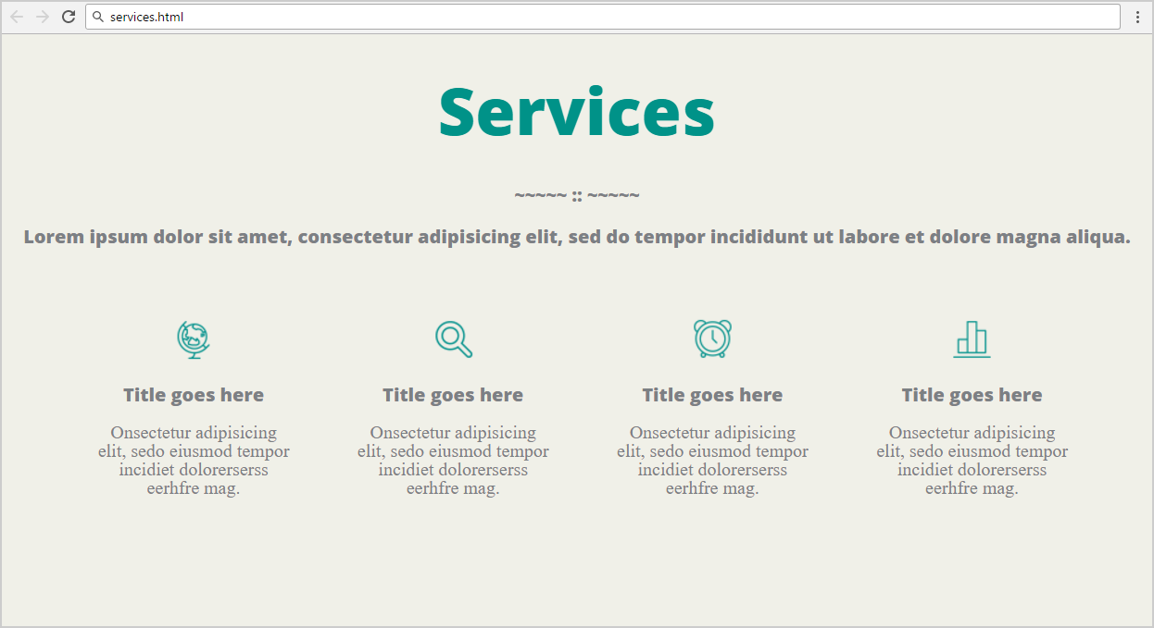

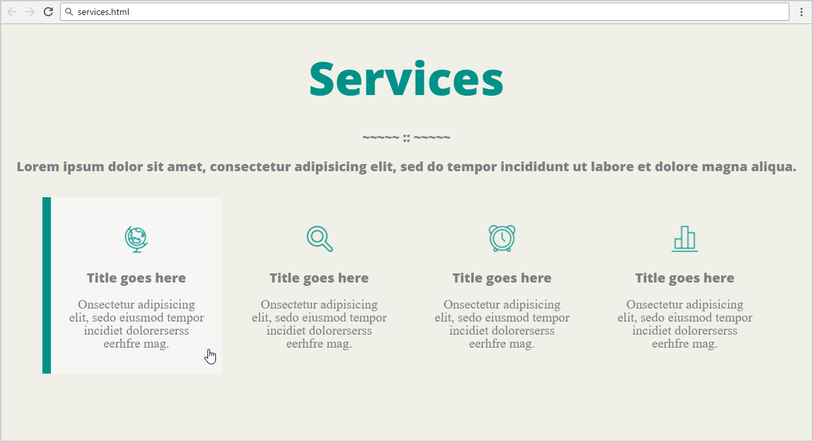

* The hand cursors in the screenshots show what happens when the mouse moves over certain elements.

### Input

You are given the above screenshots + the required font + all required images + the texts on the site.

### Output

The output should be valid HTML5 + CSS3 that implement the above Web site.

### Constraints

* The font in the entire page is OpenSans-ExtraBold / Helvetica / sans-serif (size: 56px for the main heading, 16px for the texts).
* Column width: 220px with all margins + paddings.
* There are 4 articles
* Pixel-perfect implementation is not required.